Requirement Analysis
Solution Requirements
Date | November 2, 2025
Team ID | F53C03230D9D3649CD4402B24FF15FEB
project Name | Educational organization using ServiceNow

Project: Educational Management System Using ServiceNow
Requirement Types:
- FR: Functional Requirement (What the system must do)
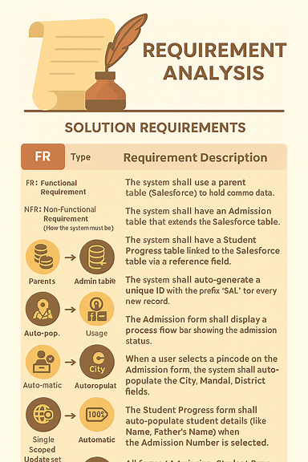
- NFR: Non-Functional Requirement (How the system must be)

ID |  |  | Type | Requirement Description
FR-01 |  |  | FR | The system shall use a parent table (Salesforce) to hold common data.
FR-02 |  |  | FR | The system shall have an Admission table that extends the Salesforce table.
FR-03 |  |  | FR | The system shall have a Student Progress table linked to the Salesforce table via a reference field.
FR-04 |  |  | FR | The system shall auto-generate a unique ID with the prefix "SAL" for every new record.
FR-05 |  |  | FR | The Admission form shall display a process flow bar showing the admission status.
FR-06 |  |  | FR | When a user selects a pincode on the Admission form, the system shall auto-populate the City, Mandal, and District fields.
FR-07 |  |  | FR | The Student Progress form shall auto-populate student details (like Name, Father's Name) when the Admission Number is selected.
FR-08 |  |  | FR | The Total, Percentage, and Result fields on the Student Progress form shall be read-only.
FR-09 |  |  | FR | The system shall automatically calculate the Total field by summing all subject mark fields.
FR-10 |  |  | FR | The system shall automatically calculate the Percentage field based on the Total (e.g., (Total / 600) * 100).
FR-11 |  |  | FR | The system shall automatically set the Result field to "Pass" (if Percentage >= 60) or "Fail" (if Percentage < 60).
NFR-01 |  |  | NFR | All forms (Admission, Student Progress) must load in under 3 seconds.
NFR-02 |  |  | NFR | Client script calculations (Total, Percentage) must execute in less than 1 second.
NFR-03 |  |  | NFR | The system must be built within a scoped application or a single global Update Set for easy migration.
NFR-04 | NFR | Field names must be consistent and easy to understand (e.g., u_student_name).

